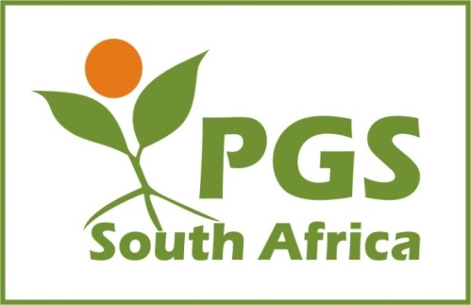
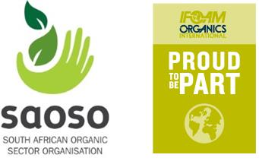

PGS South Africa
APPLICATION TO BECOME A MEMBER OF PGS South Africa
PGS South Africa (PGSSA) welcomes applications from organisations or individuals supporting the objective of establishing Participatory Guarantee Systems to facilitate market access for local organic farmers and producers, and to create an environment where consumers are assured of the integrity of organic products.
Should you have any questions regarding this membership application process, please contact Ms Sasha Mentz on sasha@pgssa.org.za

1. Membership category and fees

We hereby apply for Membership of PGSSA (please check box where applicable)
R 500.00/annum
Full member (Any PGS Group that submits the PGS self-evaluation form and wishes
to benefit from the activities and various resources of the association, including applying for approval to use the South African Organic Sector Organisation (SAOSO) PGS Endorsed organic logo for the SAOSO Standard for Organic Production and Processing.)
Supporter of PGS (no fee, donations welcomed) Donation R………………………..
________________________________________________________________________________________________
The South African Organic Sector Organisation (SAOSO) support the adoption of Participatory Guarantee Systems throughout the country. If you as an individual would like to support the objectives of SAOSO we suggest you apply for membership of their organisation. Membership costs R250 per annum. The link to apply for membership is here:

2. Contact information of PGS Group administrator, supporting organisation contact person, individual or supporter.
Name
PGS Group/Organisation Name
Telephone: |  | Mobile:
Website:
Email:
Address: (Physical)
Address: (Postal)

3. Membership payment

Payments to be made to: PGS South Africa
Bank Name: Nedbank
Current Account Number: 1084562979
Branch Code: 100909

Kindly email your proof of payment with your application form to: Raymond.Auerbach@mandela.ac.za and CC sasha@pgssa.org.za.

4. Pledge

I undertake to abide by the constitution of PGSSA, and the criteria for membership as they are developed and modified from time to time, available on request.

I further undertake to pay my annual membership fee, and to participate in the affairs of PGSSA in good faith.

Name:

Signature: Date:

Thank you for completing the application form. An invoice will be sent to you within a week of receipt and approval of your application.

PGSSA Executive Committee: Elected November 2018

Siphiwe Sithole, Chairperson: siphiwesithole78@yahoo.co.za
Matthew Purkis, Vice Chairperson: matt@saoso.org
Raymond Auerbach, Treasurer: Raymond.Auerbach@mandela.ac.za
Sasha Mentz, PGSSA Communication & Support: sasha@pgssa.org.za

PGS South Africa is a member of the South African Organic Sector Organisation (SAOSO) and IFOAM – Organics International

